Project Planning Phase
Project Planning Template (Product Backlog, Sprint Planning, Stories, Story points)

Date | 03 October 2026
Team ID | SWTID-2026-8647
Project Name | Implement Client Script & UI Policy (Incident)
Maximum Marks | 5 Marks

Product Backlog, Sprint Schedule, and Estimation (4 Marks)
Use the below template to create product backlog and sprint schedule
Sprint | Functional Requirement (Epic) | User Story Number | User Story / Task | Story Points | Priority | Team Members
Sprint-1 | Incident Form Configuration | USN-1 | As an administrator, I can configure the Incident form for consistent incident information entry. | 5 | High
Sprint-1 |  | USN-2 | As a user, I can create an Incident record with the required standard information. | 5 | High
Sprint-1 |  | USN-3 | As an administrator, I can configure Priority and State conditions for Incident form behavior. | 5 | High
Sprint-1 |  | USN-4 | As an administrator, I can configure the required Incident fields and document their expected behavior. | 5 | Medium
Sprint-2 | UI Policy and Client Script | USN-5 | As an administrator, I can create a UI Policy that changes Incident field behavior for critical or high-priority Incidents. | 5 | High
Sprint-2 |  | USN-6 | As an administrator, I can configure UI Policy Actions for mandatory, visible, and read-only field behavior. | 5 | High
Sprint-2 |  | USN-7 | As an administrator, I can configure a Client Script on the Incident table to support client-side validation and user feedback. | 5 | High
Sprint-2 |  | USN-8 | As a tester, I can verify the configured Incident form behavior for normal and critical or high-priority conditions. | 5 | Medium

Project Tracker, Velocity & Burndown Chart: (4 Marks)
Sprint | Total Story Points | Duration | Sprint Start Date | Sprint End Date (Planned) | Story Points Completed (as on Planned End Date) | Sprint Release Date (Actual)
Sprint-1 | 20 | 6 Days | 01 Oct 2026 | 06 Oct 2026 | To be verified | To be verified
Sprint-2 | 20 | 6 Days | 07 Oct 2026 | 12 Oct 2026 | To be verified | To be verified

Velocity:
For this project, the planned velocity is 20 story points per sprint with a 6-day sprint duration. The average velocity per day is calculated as story points per sprint divided by sprint duration.
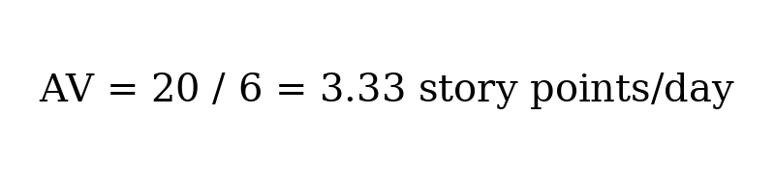

Burndown Chart:
A burndown chart is a graphical representation of work remaining versus time. For this project, it can be used to track the remaining ServiceNow Incident configuration work during each sprint.

https://www.atlassian.com/agile/tutorials/burndown-charts
https://www.atlassian.com/agile/project-management

Reference:
https://www.atlassian.com/agile/tutorials/how-to-do-scrum-with-jira-software
https://www.atlassian.com/agile/tutorials/epics

